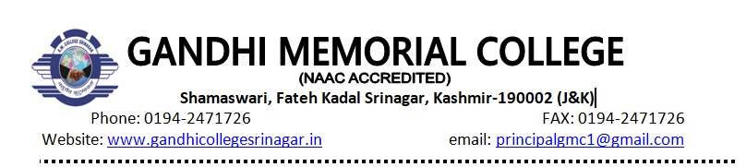

**Ref No. : GMC/HIS/APR/03** **Dated: 19/04/2024**

**Important Notice**

It is hereby notified for the information of BA Sixth Sem (Core) that their internal/viva voice examination will be held on 20/04/2024 (Saturday). The examination will commence at 11:30 AM.

**Head of Department**

**Prof. Mohammad Zubair Ud Din**

**Copyto:**

**1.Incharge website**

**2.Coordinator Examinations**

**3.Department file**