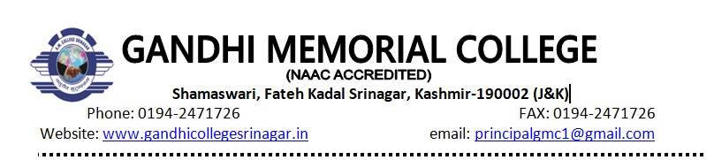

**RefNo.:GMC/HIS/APR/02** **Dated:19/04/2024**

**Important Notice**

It is hereby notified for the information of BA Sixth Sem(Elective) that their internal/viva voice examination will be held on 22/04/2024 (Monday). The examination will commence at 11:30AM.

**Head of Department**

**Prof. Mohammad Zubair Ud Din**

**Copyto:**

**1.Incharge website**

**2.Coordinator Examinations**

**3.Department file**